920W 48V High Perf. Servo Motor 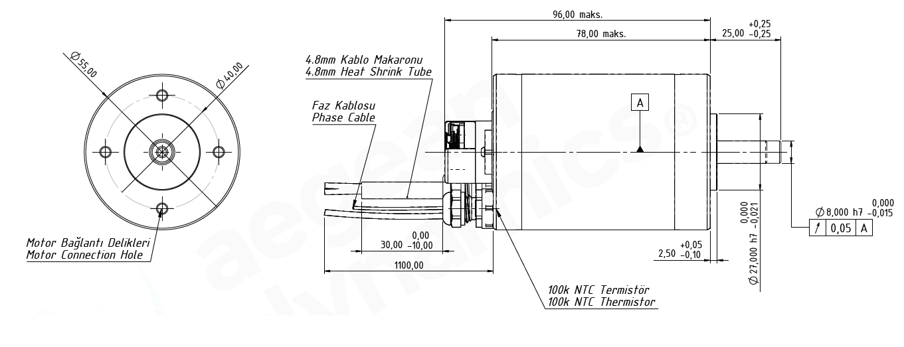
Basic Motor Parameters
Rated Power | W | 920
Rated Speed | rpm | 12800
Rated Torque | Nm | 0.68
Rated Current | A | 21
Rated Voltage | V | 48
No-Load Speed | rpm | 14000
Max. Efficiency | % | 90
Electrical Parameters
Number of Phases |  | 3
Number of Poles |  | 4
Torque Constant (KT) | Nm/A | 0.032
Back EMF Constant (KE) | Vs/rad | 0.032
Terminal Resistance Phase to Phase (±%10) | mΩ | 80
Terminal Inductance Phase to Phase (±%30) | mH | 90
Thermal Data
Ambient Temperature | °C | -40...+85
Max. Winding Temperature | °C | +155
Physical Parameters
Outer Diameter | mm | 55
Shaft Diameter | mm | 8
Max. Lenght | mm | 121
Weight | gr | ~1650
Motor Connection
U | RED CABLE
V | BLACK CABLE
W | WHITE CABLE
Sensor Connection
1 | GND
2 | VDC +
3 | Z’
4 | Z
5 | B
6 | B’
7 | A’
8 | A
9 | HALL A
10 | HALL B
11 | HALL C
Connector Articles
Power | M8 CABLE GLAND
Signal | Molex 501330-1100

